
Shoulder Institute

Adhesive Capsulitis

Introduction

Adhesive capsulitis or "frozen shoulder" is a condition of uncertain etiology characterized by significant restriction of both active and passive shoulder motion that occurs in the absence of a known intrinsic shoulder disorder. It is one of the most common and disabling orthopaedic conditions. The incidence in the general population is roughly 2 to 3%. Safe and effective treatment requires understanding of the natural history, staging, clinical evaluation, and indications / contraindications for surgical intervention.

Epidemiology

70% of frozen shoulders occur in females. Peak incidence occurs between the ages 40 and 60 years old. It can occur in either the dominant or nondominant shoulder. There is a strong association with diabetes, thyroid disease, stroke, myocardial infarction, trauma and immobilization. Later occurrence in the contralateral shoulder is seen in 30% of cases.

Classification

Primary adhesive capsulitis is by definition idiopathic (no identifiable associated condition). Secondary adhesive capsulitis are those cases associated with extrinsic or systemic conditions.

Natural History

Classic teaching about idiopathic adhesive capsulitis is that it is a self-limited condition lasting 12 to 18 months. However this disease may not be so "self-limited". Several studies show that approximate 50% of patients even seven years after the thawing phase have persistent complaints of pain, stiffness and range of motion restrictions. Despite their symptoms and restriction most patients are minimally impaired. Recurrence in a previously affected shoulder is extremely rare. The literature suggests that adhesive capsulitis associated with diabetes shows greater severity and a poorer prognosis.
Page 2 – Adhesive Capsulitis

Staging of Adhesive Capsulitis

Stage 1 is also known as the "painful phase". The duration is between 0 and 3 months. Pain is seen with active and passive range of motion. External rotation activities are particularly sensitive. There is limitation of forward flexion, abduction, internal rotation and external rotation. Interestingly, at this stage there is no true loss of range of motion. Inside the shoulder, however, there is diffuse synovitis especially in the anterosuperior shoulder capsule.

Stage 2 is the "freezing phase". This lasts between 3 and 9 months. Patients complain of chronic pain with active and passive range of motion. There is true, significant limitation of motion in all planes. Inside the shoulder there is diffuse hypertrophic, hypervascular synovitis and thickening of the capsule.

Stage 3 is the "frozen phase". The duration of this phase can be between 9 and 14 months. There is minimal pain during this phase except at the end ranges of motion. There is significant limitation of range of motion with a rigid endpoint. Inside the shoulder the hypervascularity is absent but the shoulder capsule is thickened and the volume of the shoulder is decreased.

Stage 4 is the "thawing phase". This can last between 15 and 24 months. There is minimal pain during this time. Progressive improvement in range of motion is seen.

Diagnostic Evaluation

The history generally reveals an atraumatic, insidious onset with the patient complaining of pain and / or stiffness. The physical examination will show restriction in the range of motion. Plain radiographs are most often normal. MRI with intra-articular gadolinium generally only shows diminished capsular volume. It is important to rule out other causes of stiffness including trauma, degenerative joint disease, cervical spine disease and rotator cuff pathology.

Treatment Approach

The plethora of alternative treatment options suggests that there is no single "best" option. Treatment must be individualized based on the patient, staging disease and response to treatment. In Stages 1 and 2 patient education is of great importance. Patients need to understand that the recovery can take a long time and that their best chance of regaining motion and function is through their own active participation through a home program.

Page 3 – Adhesive Capsulitis

We recommend a home-exercise stretching program (University of Washington protocol). The four stretches are 1) overhead reach, 2) external rotation, 3) internal rotation and 4) cross-body reach. The forward elevation stretch is affected by lifting your stiff arm up as high as it will go, lying on your back in using the opposite arm to grasp the affected rest lifted overhead and holding it. Alternatively, one can use a "progressive forward lean" method in which the body weight is used to apply force to the elevated arm.
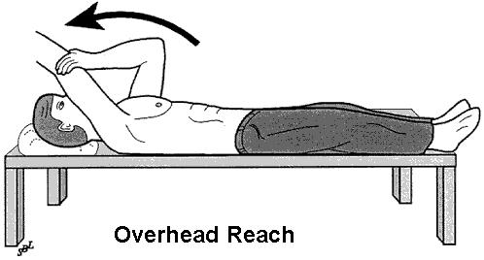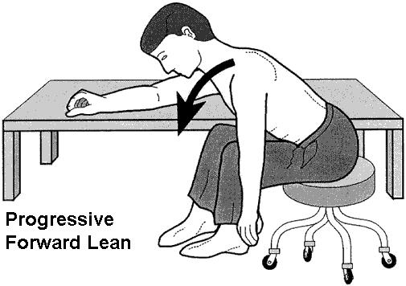

External rotation is done while supine using the cane or stick using the normal arm to rotate the hand of the stiff shoulder out and away from the body. Alternatively, one may rotate the body with the hand fixed on the side of the door frame or corner to stretch the anterior structures, sustaining the stretch for a 100 count.

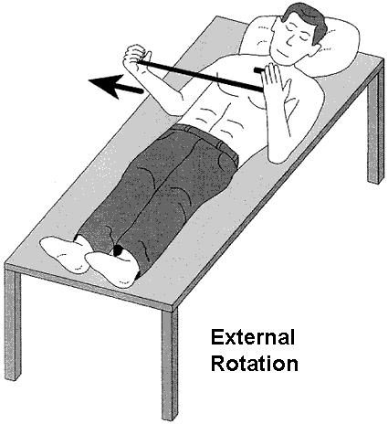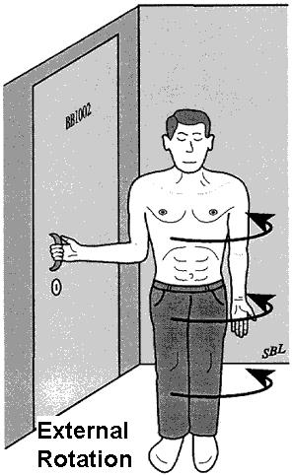
Page 4 – Adhesive Capsulitis

Internal rotation is performed by using a towel behind your back, relying on your normal shoulder to stretch your affected one. Alternatively, one may grasp something fixed behind you (e.g. doorknob) and by bending your needs thereby stretching out your own shoulder.
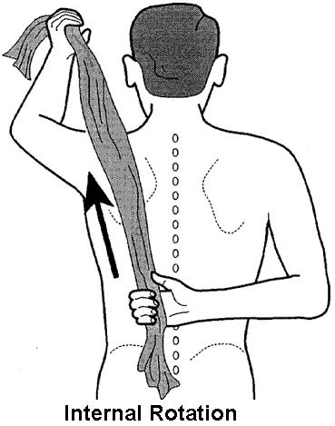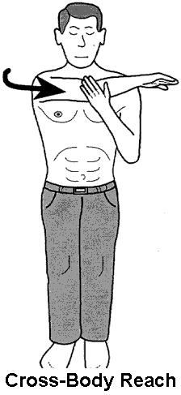

Cross-body reach is performed by using your normal wrist to grasp the elbow of the affected extremity and pull across your body holding it there. We recommend performing these exercises at least three times a day. The stretches should be performed gently without using vigorous force. Hold all stretches for account of 100 if possible. Soreness should resolve within 30 minutes, however, if soreness persists you should decrease the stretch and intensity. The stretching program should be modified according to the pattern of tightness. You are encouraged to remain as active as possible. Injections of corticosteroids are frequently used during these stages.

Your opposite arm is a great therapist for your stiff shoulder. Your "therapist arm" is always available to apply a gentle stretch in any direction of tightness.
Many patients are reluctant to try this stretching and aerobic program because they have already had “therapy." Our repeated observation is that many patients who have not responded to formal therapy sessions can improve their shoulder function using this home program. Remember that your shoulder stiffness has been present for quite a while. Improvement in your range of motion and comfort may not begin until six weeks of persistence with the program. You should not stop these exercises until your shoulder has regained normal motion and comfort.
Patients in Stage 3 are candidates for surgical intervention. However, nonoperative treatments continue until the patient plateaus without any further gain in range of motion or the impairment forces intervention. Swimming is an excellent functional exercise. It should be emphasized that most patients will not require surgical intervention.
Page 5 – Adhesive Capsulitis
We have found that medication is not very helpful in managing stiff shoulders. Mild analgesics (such as aspirin, ibuprofen, or acetaminophen) may be used in conjunction with this program if desired. Narcotic medications, "muscle relaxants" and sleeping pills have not proved helpful to our patients.
Alternative medicine treatments such as acupuncture have proven to be quite successful in many of our patients.
Conclusions

The initial treatment should always been nonoperative. Definitive treatment is usually nonoperative. The timing of surgical intervention must be individualized. Corticosteroids are valuable to relieve pain and to help resolve the initial two stages. Most patients with refractory frozen shoulders require arthroscopic releases. As with all surgeries, complications (while rare) can and do occur. Most reports suggest that arthroscopic capsule releases are very effective in both the short and long-term. In any case, diabetics seem to have a worse prognosis than nondiabetics.
Regular fitness exercise helps keep your joints supple. This "lubricating" effect is optimized if you perform a half-hour of aerobic exercise each day. You may be able to use the shoulder actively within the range of comfort. For example, if you can do some water exercises or swimming without aggravating the shoulder, please do so. On the other hand, activities which produce shoulder pain should be avoided.
Please feel free to ask questions of us.

