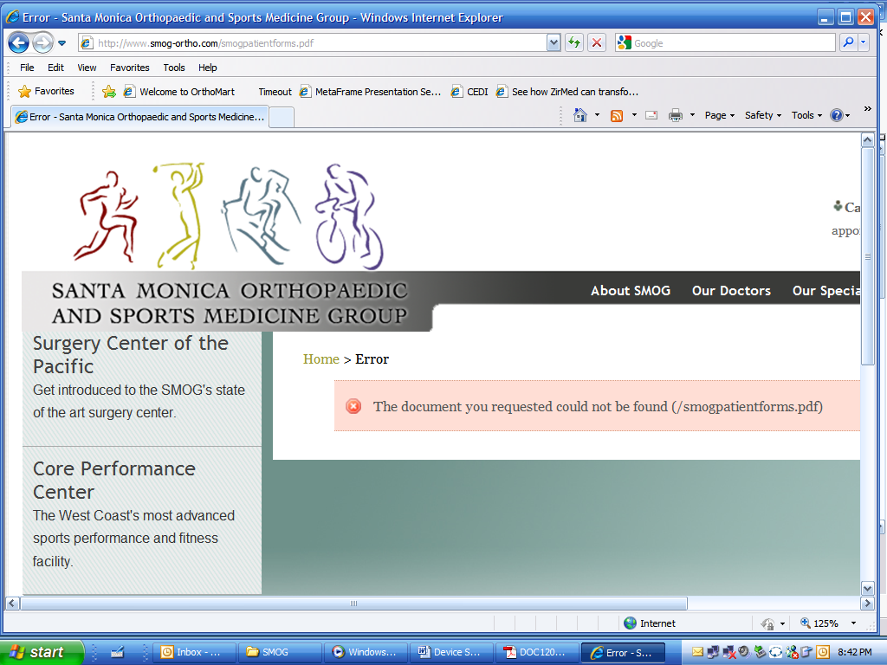 | NOTICE OF PRIVACY  PRACTICES  Effective 4/14/03 | Santa Monica Orthopaedic and Sports Medicine Group  2020 Santa Monica Blvd Suite 400  Santa Monica, CA 90404  Phone: (310) 829-2663

This Notice describes how medical information about you may be used and
disclosed and how you can get access to this information Please review it carefully.
We understand that your medical information is personal and we are committed to protecting this information. We create a record of the equipment, services, and financial information about you. We use this record to provide you with quality equipment and services, and to comply with the certain legal requirements. This Notice applies to all of our records pertaining to your care. This Notice will tell you about the ways in which we may use and disclose your medical information. We also describe your rights and certain obligations we have regarding the use and disclosure of your medical information. Privacy laws require that we ensure the following:  - We must maintain the privacy of your medical and financial information;  - We must provide you with this Notice, which explains our legal duties and privacy practices with respect to your protected health information; and,  - We must follow the terms of the Notice currently in effect.  HOW WE MAY USE AND DISCLOSE MEDICAL INFORMATION ABOUT YOU  The following categories describe different ways that we can use and disclose protected health information. We will define and give some examples for each category of uses or disclosures listed below. Not every use or disclosure in a category will be listed. However, all of the ways we are permitted to use and disclose information will fall within one of the categories.  For Payment – We may use and disclose your protected health information so that the equipment and services you receive may be billed to and payment may be collected from you, your insurance company or a third party. For example, we may need to give your insurance company information about a type of surgery you received at the hospital, so your insurance will pay us or reimburse you for the equipment you now require. We may also tell your health plan about the equipment you are going to receive to obtain prior approval or to determine whether your plan will cover that equipment.  For Health Care Operations – We may use your protected health information to evaluate the performance of our employees who serve you. For example, we may combine information about many of our patients to decide what additional services we should offer or what services are no longer necessary. We may also disclose information to doctors and other health care professionals that are also required by law to follow these privacy guidelines.  For Treatment – We may use your protected health information to provide you with medical equipment or services. For example, we may gather information from your health care provider, such as a physician, nurse, or other person providing health services to you, and maintain that information in your record. This information is necessary for health care providers to determine what treatment you should receive. | Health-related Benefits and Services – We may contact you to tell you about health-related benefits or services that may be of interest to you.  Individuals Involved in Your Care or Payment for Your Care – We may release your protected health information to a friend or family member who is involved in your medical care or who helps pay for your care.  As Required By Law – We will disclose our protected health information when required to do so by federal, state, or local laws.  To Avert a Serious Threat to Health or Safety – We may use and disclose your protected health information when necessary to prevent a serious threat to your health and safety or the health and safety of the public or another individual. Any disclosure, however, would only be to someone able to help prevent that threat.  Public Health Risks – We may disclose your protected health information for public health activities.  Health Oversight Activities – We may disclose your protected health information to a health oversight agency for activities authorized by law. These oversight activities include, for example, audits, investigations, inspections, and licensure. These activities are necessary for the government to monitor the health care system, government programs, and compliance with civil rights laws.  Lawsuits and Disputes – If you are involved in a lawsuit or dispute, we may disclose medical information about you in response to a court or administrative order. We may also disclose medical information about you in response to a subpoena, discovery request, or other lawful process by someone else involved in the dispute, but only if efforts have been made to tell you about the request or to obtain an order protecting the information requested.  Law Enforcement – We may release your protected health information if asked to do so by law enforcement officials.  National Security and Intelligence Activities – We may release your protected health information to authorized federal officials for intelligence, counterintelligence, and other national security activities authorized by law to include protection of the President, other authorized persons or foreign heads of state, or in conducting special investigations.
YOUR RIGHTS REGARDING YOUR PROTECTED HEALTH INFORMATION  Right to Inspect and Copy – In accordance with 45 C.F.R. §164.524, you have the right to inspect and copy medical information that may be used to make decisions about your care. To inspect and copy your protected health information that may be used to make decisions about you, you must submit your request in writing to our Office Manager. We may deny your request to inspect and copy in certain, very limited, circumstances. If you are denied access to medical information, you may request that the denial be reviewed. A licensed health care professional chosen by Santa Monica Orthopaedic and Sports Medicine Group will review your request and the denial. The person conducting the review will not be the person who denied your request. We will comply with the outcome of the review.  Right to Amend – In accordance with 45. C.F.R. §164.526, if you feel that your protected health information that we possess is incorrect or incomplete, you may ask us to amend the information. You have the right to request an amendment for as long as the information is kept by or for Santa Monica Orthopaedic and Sports Medicine Group. To request an amendment, your request must be made in writing and submitted to the Santa Monica Orthopaedic and Sports Medicine Group Office Manager. Contact the Office Manager at their address for a request letter. You must provide a reason that supports your request. We may deny your request for an amendment if it is not in writing or does not include a reason to support the request. In addition, we may deny your request if you ask us to amend information that is accurate and complete.  Right to an Accounting of Disclosures – In accordance with 45 C.F.R. §164,528, you have the right to request an accounting of disclosures. This is a list of instances in which we disclosed your protected health information. To request this account of disclosures, you must submit your request in writing to our Office Manager. Your request must state a time period, which may not be longer than six years and may not include dates prior to April 14, 2003. The first accounting of disclosures you request within a 12 month period will be free. For additional accountings, we may charge you for the costs of providing the list. We will notify you of the cost involved, so you may choose to withdraw or modify your request at that time before any costs are incurred.  Right to Request Restrictions – In accordance with 45 C.F.R. §164.522(a), you have the right to request a restriction or limitation on the protected health information we use or disclose about you for treatment, payment or health care operations. You also have the right to request a limit on the protected health information we disclose about you to someone who is involved in your care or the payment for your care, like a family member or friend. For example, you could ask that we not tell a spouse about a medical procedure you recently had in a hospital.  We are not required to agree with your request. If we do agree with your restriction request, we will comply unless the information is needed to provide you emergency treatment. To request restrictions, you must make the request in writing to our Office Manager. In your request, you must tell us (1) what information you want to limit; (2) whether you want to limit our use, disclosure, or both; and (3) to whom you want the limits to apply, for example, disclosure to your spouse. | Right to Receive Confidential Communications – In accordance with 45 C.F.R. §164.522(b), we communicate with you about confidential medical matters in a certain way or at a certain location. For example, you can ask that we only contact you at work or by mail. To request confidential communications, you must make your request in writing to our Office Manager. We will not ask you the reason for your request. We will accommodate all reasonable requests. Your request must specify how or where you wish to be contacted.  Changes To This Notice – We reserve the right to change this Notice. The provisions in the new Notice will be effective for all protected health information that we maintain about you.  Complaints – If you believe your privacy rights have been violated, you may file a complaint with Santa Monica Orthopaedic and Sports Medicine Group or with the Secretary of the Department of Health and Human Services. To initiate a complaint, please contact our Office Manager. To take action, all privacy complaints must be submitted in writing. You will not be retaliated against for filing a complaint.  Other Uses of Protected Health Information – Other uses and disclosures of your protected health information not covered by this Notice or the laws that apply to us will be made only with your written permission. If you provide us permission to use or disclose medical information about you, you may revoke that permission, in writing, at any time. If you revoke your permission, we will no longer use or disclose medical information about you for the reasons covered by your written authorization. You understand that we are unable to take back any disclosures we have already made with your permission, and that we are required to retain our records of the care that we provided to you.

